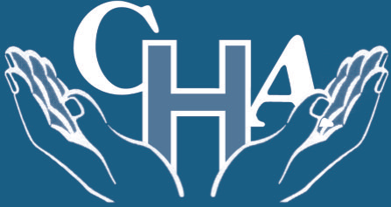

Community Hospitals Association Improving Practice

Innovation and Best Practice Award 2018 Summary
Title:
Branching out into social media to share good practice

Background:
Just over three years ago the feeling was all the negative points of practice were concentrated on…what targets we had not met and what we needed to improve on. The culture did not seem to be positive.

There were so many little things that make such a difference to our patients that the staff did on the ward where they went the extra mile to improve care standards for our patients that did not appear to be recognised or celebrated. With the help of our communications team our Twitter site was born.
Description:
The way in which Scotter Ward are using social media to increase the profile of the ward in the wider community, demonstrating a vision to embrace different ways of staff and public engagement, share good news, bench mark good practice, share ideas and aspirations, keep abreast of local and national initiatives and show how they support staff and patients through education.

The Scotter Ward team have worked hard over the last few years to promote and strengthen its reputation and the reputation of the trust. One way of doing this is via its own Twitter site and in this time has built up a follower base of nearly two thousand followers.

We are the only in-patient facility in the trust to share our good news and practice on the ward in this way.

The site has regular retweets and receives at least 70-100 notifications a day.

We also have an Instagram and Facebook page.

We have embraced the website Fab NHS Stuff and have had over 30 articles published on the site showcasing our ideas that have improved patient care and experience on the ward.
Outcome and Impact:
Scotter Ward is now well respected in the social media society. We have had many visits to the ward from other Organisations that are following us and want to visit to see what we do and share their ideas. We are currently working on ‘twinning’ with a local Mental Health Trust ward to share best practice and ideas, all of which was born through connecting through social media.

We won the Picalilley award at the National FAB NHS Awards at the O2 in London in Nov 2016.
Donna our Clinical Team Lead won the Individual Change Week Champion Award at the FAB NHS Awards at the O2 in London in Nov 2017.

Donna also won the Nurse of the Year award for the first ever Lincolnshire Health Awards in November 2017.

All this ultimately raises the profile of the ward building on and strengthening the good reputation the ward and trust has and information gained increases the standard of care that we can give to our patients.

Our work on Twitter and our articles that we have shared on Fab NHS Stuff have resulted in Donna the Clinical Team Lead being invited to be one of the first ever Fab NHS Stuff Ambassadors in the whole country and she is now the Regional Coordinator for FAB NHS Stuff for Lincolnshire and actively encourages others to share their work too.
Supporting Information:
Organisation:
Scotter Ward
John Coupland Hospital
Lincolnshire Community Health Services
Contact details:
Donna Phillips
Clinical Team Lead
01427 816542
Donna.phillips@lincs-chs.nhs.uk
CHA Judges Comments:
The wards use of social media is one of the best examples of a community hospital sharing information about its services and good practice. The use of social media allows staff to do justice to the very good work they do on the ward. The message from the communication systems is that patients are first and foremost and that all staff are involved in exploring ways of improving services.

